**1. Create Table Name : Student**

CREATE TABLE student(rollno int primary key, name varchar(250), branch varchar(250));



INSERT INTO student values('1','Jay','Computer Science');

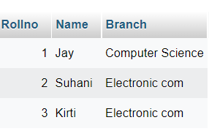

**2. Create Table Name : Exam**

CREATE TABLE exam(rollno int foreign key ,s_code varchar(55),marks float, p_code varchar (55));



INSERT INTO exam(rollno,s_code,marks,p_code)VALUES('1','cs12','60','cs')

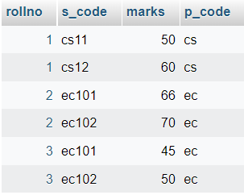

**3. Create table given below:**

CREATE TABLE detail(firstname varchar(250),lastname varchar(250),address varchar(250),city varchar(250), age int);



INSERT INTO detail(firstname,lastname,address,city,age)VALUES('mickey','mouse','123 fantasy way','anaheim','73');

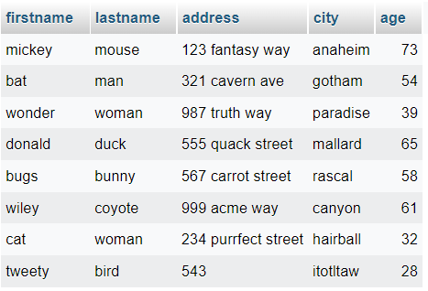

**3. Create table given below: Employee**

CREATE TABLE employee(employee_id int,first_name varchar(250),last_name varchar(250),salary float,joining_date date,department varchar(250));



INSERT INTO employee(employee_id,first_name,last_name,salary,joining_date,department)values

('1','john','abraham','1000000','13-01-01','banking');

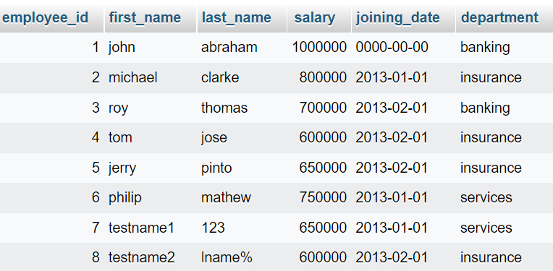

**3. Create table given below: Incentive**

CREATE TABLE incentive(employee_ref_id int,incentive_date date,incentive_amount float);



INSERT INTO incentive(employee_ref_id,incentive_date,incentive_amount)values('1','13-02-01','5000');

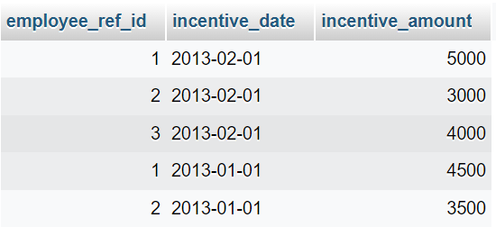

1. **Get First_Name from employee table using Tom name “Employee Name”.**

SELECT *from employee WHERE first_name='tom';

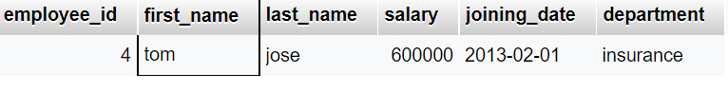

1. **Get FIRST_NAME, Joining Date, and Salary from employee table.**

select first_name,joining_date,salary FROM employee;

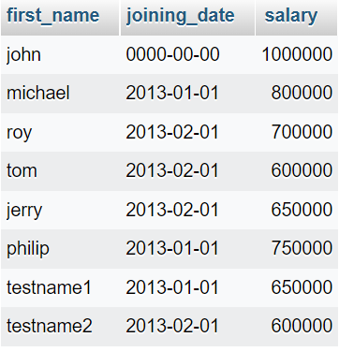

1. **Get all employee details from the employee table order by First_Name Ascending and Salary descendin**g?

SELECT * FROM employee

ORDER BY first_name ASC, salary DESC;

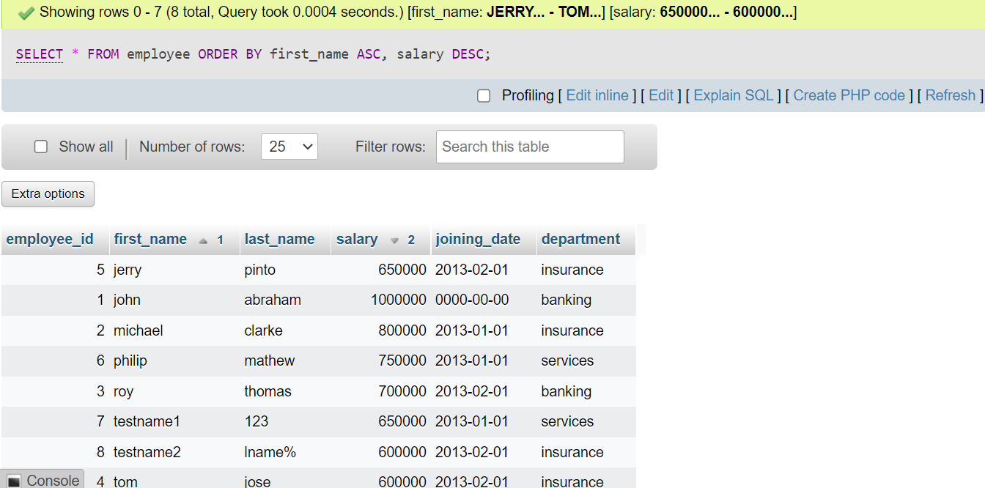

1. **Get employee details from employee table whose first name contains ‘J’.**

SELECT *FROM employee WHERE first_name LIKE '%j%';

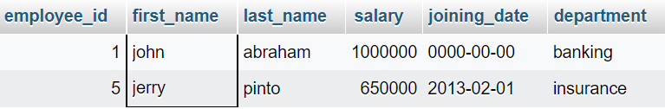

1. **Get department wise maximum salary from employee table order by salary ascending?**

SELECT MAX(salary),(department)

FROM employee

ORDER BY salary asc;

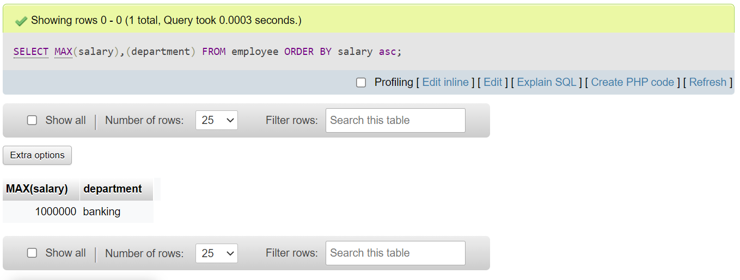

1. **Select first_name, incentive amount from employee and incentives table for those employees who have incentives and incentive amount greater than 3000**

SELECT first_name,incentive_amount

FROM employee

Inner join incentive on employee_id = employee_ref_id and incentive_amount>3000;

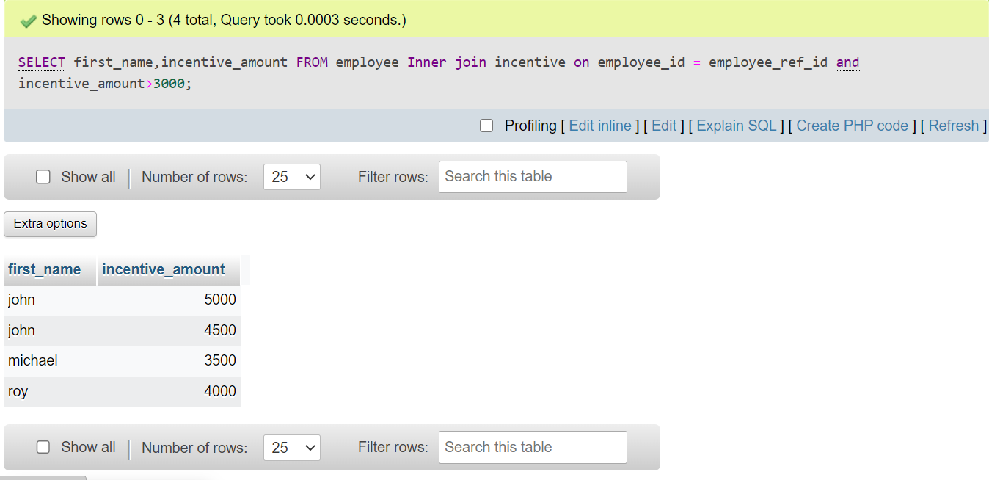

1. **Create After Insert trigger on Employee table which insert records in view table**

CREATE TRIGGER after_insert

ON employee

AFTER INSERT

AS

BEGIN

INSERT INTO employee_emp(emp_id,insert_time)VALUE (new.emp_id,current_time());

END

**4.Create table given below: Salesperson**

Create table salesperson(sno int primary key,sname varchar(250),city varchar(250),comm varchar(250));

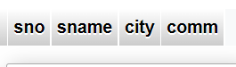

INSERT INTO salesperson(sno,sname,city,comm)VALUES('1001','peel','london','.12');

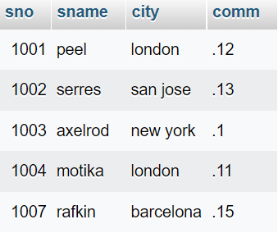

**4. Create table given below: Customer**

CREATE TABLE customer (cnm int PRIMARY KEY,cname varchar(55),city varchar(55),rating INT,sno INT);

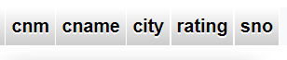

insert into customer(cnm,cname,city,rating,sno)values('201','hoffman','london','100','1001');

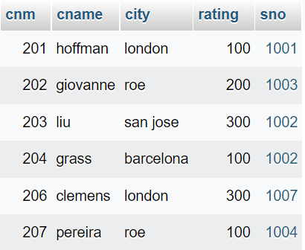

**5. Create table given below: order**

CREATE TABLE oder(onm int primary key,amt float, ode date , FOREIGN KEY (cnm)REFERENCES customer (cnm) , FOREIGN KEY (sno) REFERENCES salesperson (sno));

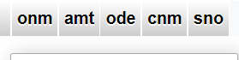

INSERT INTO oder(onm,amt,ode,cnm,sno)VALUES('3001','18.69','1994-10-03','201','1007');

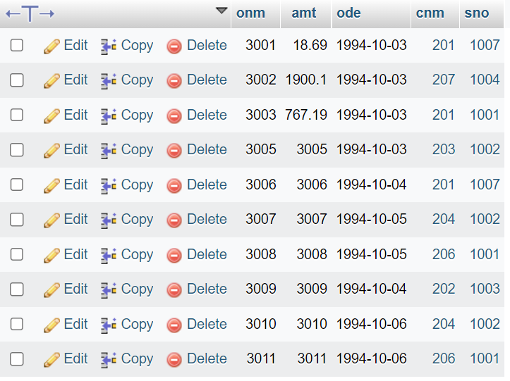

**Retrieve the below data from above table**

1. **All orders for more than $1000.**

Select * from orders where Amt>1000;

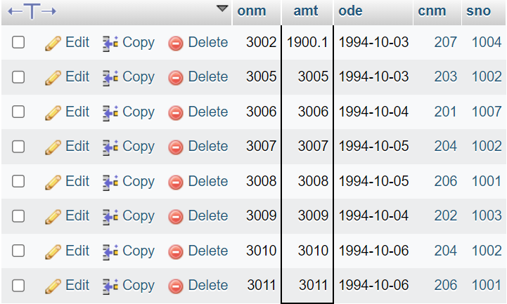

1. **Names and cities of all salespeople in London with commission above 0.12**

SELECT sname,city

FROM salesperson

WHERE city = 'london' and comm >=0.12;

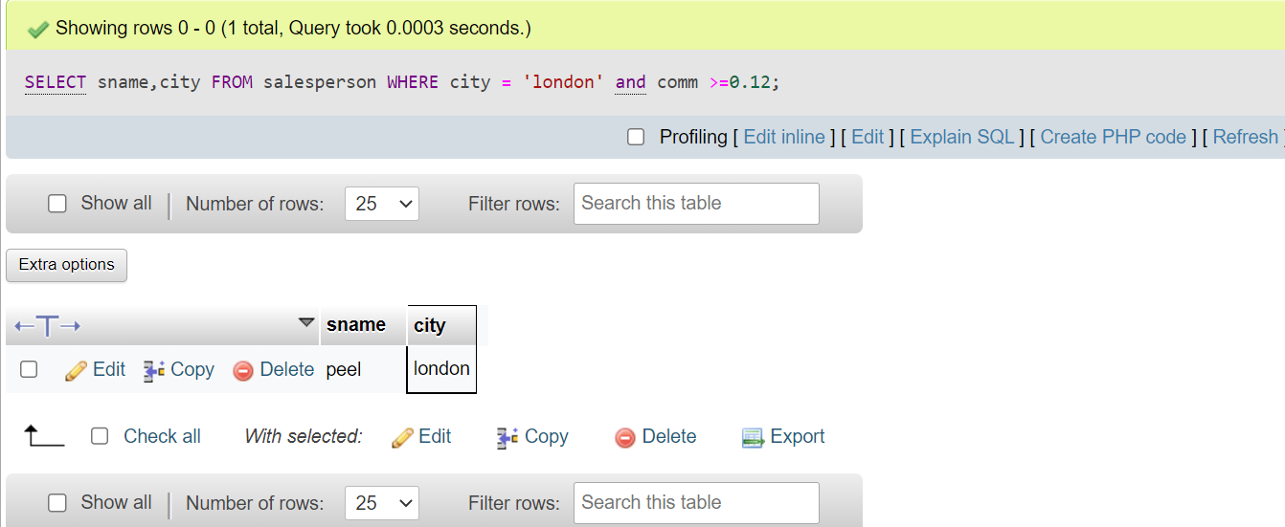

1. **All salespeople either in Barcelona or in London**

SELECT * FROM salesperson

WHERE city BETWEEN ' Barcelona 'AND'london'

ORDER BY city;

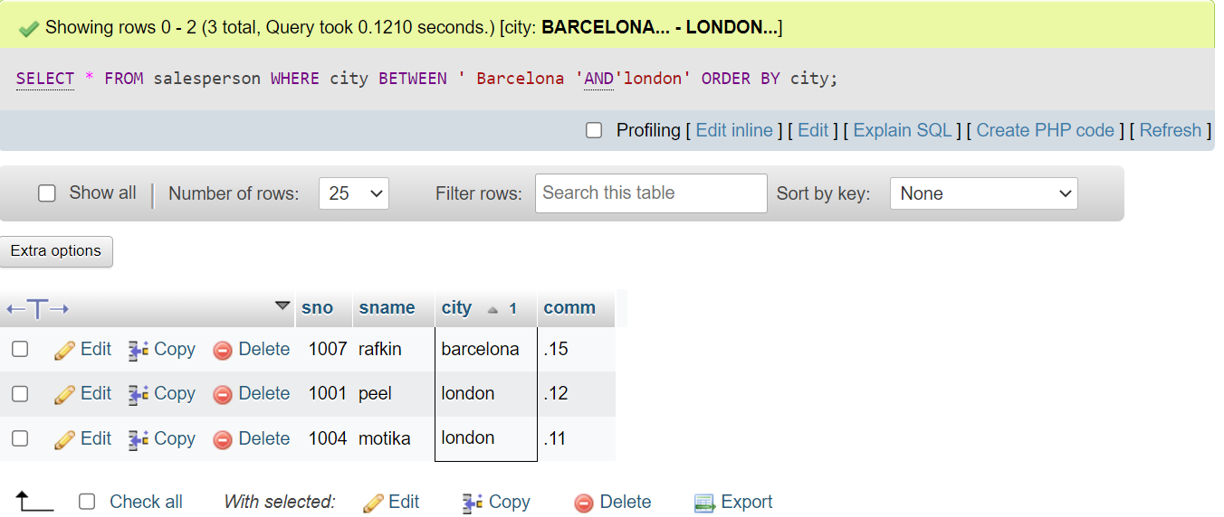

1. **All salespeople with commission between 0.10 and 0.12. (Boundary values should be excluded).**

SELECT * FROM salesperson WHERE comm BETWEEN 0.10 AND 0.12;

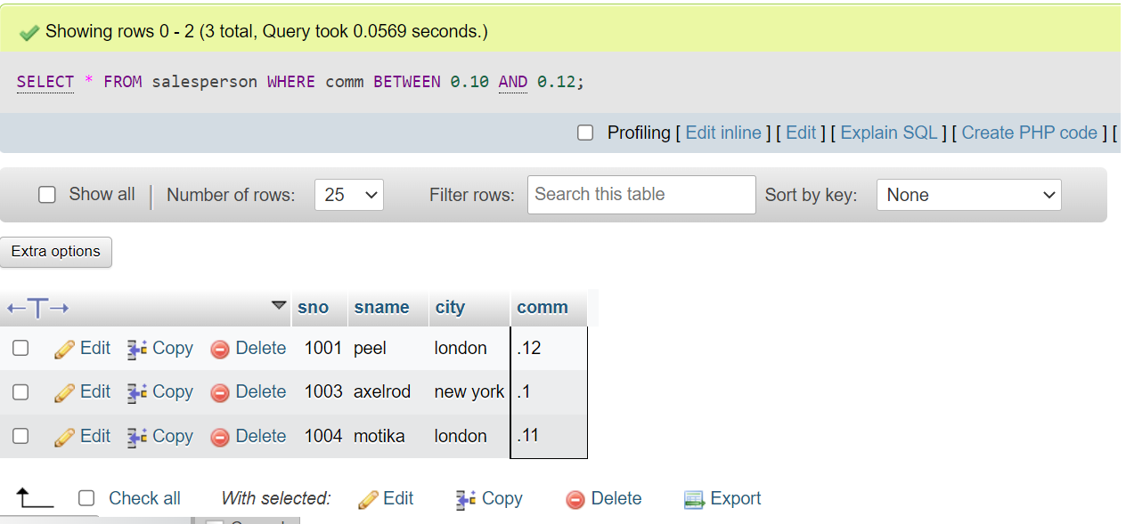

1. **All customers excluding those with rating <= 100 unless they are located in Rome**

SELECT *

FROM customer

WHERE rating <=100 and city='roe';

